Chapter 3: Energy

3.1 Energy can be transferred

Literacy support worksheet answers (pages 40–43)

Energy transfers

1 What is an energy transfer?

When energy is passed from one object to another

2 In the diagram below, you can see the transfer of energy from one object to another. What is the name given to:

a The transfer of energy fron the sun to plants:

Photosynthesis

b The transfer of energy from plants to humans:

Consuming

3 For each of the pictures below, label the type of energy:

|  |  |  |  |
| --- | --- | --- | --- |
| Heat | Electricity | Sound | Light |
| Solar | Chemical | Chemical | Kinetic |
| Kinetic | Kinetic | Electrical | Gravitational |

4 Draw a flowchart, showing the transfer of energy, like the diagrams on page 40–43. The first one has been done for you:

a The sun’s energy to an iPhone

Solar → electricity → chemical (battery) →electrical → heat/light/sound

b Chemical energy in coal to a toaster

Chemical → electricity → heat

c Tidal energy (which generates electricity using a turbine) to a tv

Kinetic (tides) → kinetic (turbine) →electricity → heat/light/sound

d Chemical energy (battery) to a car radio

Chemical → electricity → sound

e The sun’s energy to a person bouncing a basketball

Solar → chemical (plants) → chemical (humans) → kinetic

Word detective

5 Matching meaning

Draw a line to match each type of energy below (the words on the left) with its meaning (on the right):

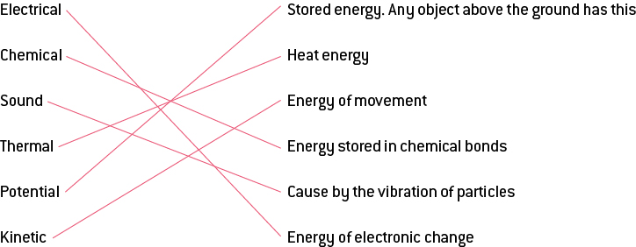

One type of energy is missing from this list. What is it?

Light

3.2 Potential energy is stored energy

Literacy support worksheet answers (pages 44–45)

Potential energy is stored energy

1 What is potential energy?

Energy that is stored in objects and available to be used is potential energy.

2 What are the four types of potential energy? Give an example of each.

a Gravitational – a person sky diving

b Chemical – a bomb exploding/a battery

c Elastic – a trampoline

d Nuclear energy

3 In the table below, label each picture as having one of each of these types of potential energy:

|  |  |  |  |  |
| --- | --- | --- | --- | --- |
| chemical |  | gravitational |  | elastic |
| gravitational |  | elastic |  | nuclear |
| chemical |  | chemical |  | gravitational |

4 Potential energy is used in children’s playgrounds. Choose five pieces of equipment below and name the type of equipment, the type of potential energy they use and the movement they make. The first one has been done for you.

|  |  |  |
| --- | --- | --- |
| Equipment | Potential energy | Movement/Motion |
| a springboard | elastic potential energy | propels you up to jump into water |
| b basketball hoop | gravitational potential energy | ball moves down through the basket |
| c horse ride | elastic potential energy | propels you upright if you adjust your weight so gravity pulls down |
| d swing | gravitational potential energy  chemical potential energy | pulls you down  used to swing your body higher |
| e slide | gravitational potential energy | pulls you down after you have climbed up |

Word detective

6 Secret message

Use words from the student book to work out the secret message below:

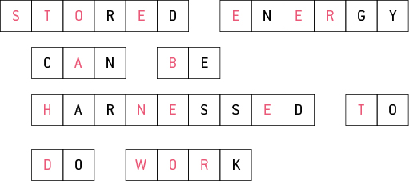

3.3 Moving objects have kinetic energy

Literacy support worksheet answers (pages 46–47)

Kinetic energy

1 What is kinetic energy?

The energy of motion is kinetic energy.

2 Do larger objects or smaller objects have the greatest kinetic energy?

Heavy, fast-moving objects have the greatest kinetic energy.

3 Give four examples of kinetic energy.

a A moving rollercoaster

b A wheel turning

c You, writing your answer to this quastion

d Water flowing down a hill

4 The larger the object the greater the kinetic energy. The faster the object, the greater the kinetic energy. Circle which object has greatest kinetic energy in each question.

a Sprinter

b Train (both going at 100kms/hour)

c Electricity

d Motorcycle (60km/hr)

5 When we are talking about energy, what is work? Circle the correct answer.

When a force moves an object

6 What is electrical energy?

The energy associated with electric charge, either stationary or moving is electrical energy.

7 What is hydroelectricity?

It is the production of electrical power from falling or flowing water.

8 How is electrical power made in a hydroelectric power station?

Electrical power is made by the kinetic energy of falling water (flowing water).

9 How could an asteroid, only 15 kilometres wide, change the climate conditions on Earth?

It blasted soil and rocks into the atmosphere, blocking out the Sun.

10 How was the same asteroid able to wipe out more than half the species on Earth?

Most (over half) life that relied on the sun died – plants, then herbivores, then carnivores etc.

11 Newton’s Second Law: Force equals the mass of an object multiplied by acceleration (F= ma). Heavier objects (mass) are harder to push (force), so they cannot move as fast (acceleration). Lighter objects are easier to push, so they can move faster.

a An elephant and a mouse are on skateboards. If you were to push both, at the same time, using the same amount of force, which would go further? Fill in the gaps using Newton’s second law.

The mouse would go faster because it is lighter so could travel at a higher speed.

Word discovery

12 Matching meaning

Draw a line to match each word on the left with the corresponding description on the right.

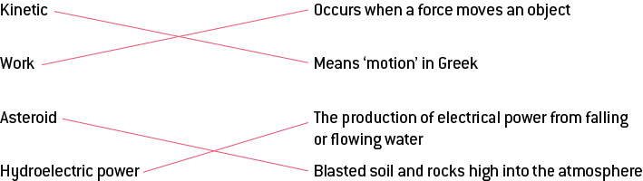

3.4 Energy can be transformed

Literacy support worksheet answers (pages 48–49)

Energy transformations

1 Name a device that will convert:

a Chemical to electrical energy:

battery

b Chemical into heat energy:

chemical heat pack/an explosion

c Electricity to light:

light bulb

d Chemical energy into sound:

an explosion/fireworks/phone/iPod

e Electricity to heat:

heater kettle

f Potential to kinetic energy:

falling/slide

g Chemical energy to light:

lighting a match

h Kinetic energy to sound:

striking a bell

2 Draw a flow diagram for each of the following energy changes. The first one has been done for you:

a A light turns on.

Chemical potential energy (coal) → Electrical → Light

b A toaster cooks your toast.

Chemical potential energy (coal) → Electrical → Heat

c A church bell is struck.

Chemical potential energy (food) → Kinetic energy → Sound

d A firework explodes.

Chemical potential energy (explosives) →Kinetic energy (through air) → Heat, light and sound

3 Why does a mug of hot chocolate eventually cool down? Where does the heat energy go?

Heat is lost to the surrounding atmosphere/air.

4 What will happen to a glass of ice cold water if left at room temperature?

The heat in the atmosphere will transfer to the water in the glass, heating it up.

5 Does the hot chocolate or the cool lemonade have more thermal energy? Explain your answer.

The hot chocolate will have more thermal energy, as the more thermal energy an object has, the hotter it is.

6 Which of the drinks in question 6 will have more thermal energy if they are left on the same bench overnight?

They will both reach room temperature overnight and have the same amount of thermal energy.

7 Draw a diagram of the energy conversion when using a microwave oven.

Student diagrams will vary

Word discovery

8 True or false

Read each statement below and circle whether it is true or false.

a Energy constantly changes from one form to another.

T

b Clouds are light as a feather.

F

c Burning coal releases chemical energy.

T

d Heat is the transfer of energy from a lower to a higher temperature.

F

e As coffee cools the kinetic energy in its particles increase.

F

f Thermal energy is the same as kinetic energy.

F

g Vibrations are sound energy.

T

3.5 Energy cannot be created or destroyed

Literacy support worksheet answers (pages 50–51)

Energy efficiency

1 What is energy efficiency?

Energy efficiency is a calculation of the percentage of useful energy transformed.

2 What is the law of conservation of energy?

Energy cannot be created or destroyed.

3 Energy conversions are not 100% efficient. Why not?

Energy is transformed into heat and sound energy as well as the desired form of energy.

4 If a light globe was 100% energy efficient what would it do?

It would only convert electricity to light.

5 Use the table below to compare the efficiency of the following three light globes:

|  |  |  |  |
| --- | --- | --- | --- |
|  | a Incandescent bulb | b Compact fluorescent light | c Light-emitting diode |
| % Light conversion | 5 | 10 | 30 |
| % Heat conversion | 95 | 90 | 70 |

6 Which of these three bulbs is the most energy efficient?

The light is most energy efficient emitting diode as it converts more electricity into light.

7 Using the equation for energy efficiency, calculate the efficiency of each of the three light bulbs.

The first one has been done for you:

a Incandescent bulb: 

b Compact fluorescent light: 

c Light-emitting diode: 

8 Do your answers for question 5 match with your answers for question 7? Why/Why not?

Yes, the calculations prove that the light emitting diode will have a greater percentage of electricity converted into light, therefore it is more energy efficient as less electricity is wasted.

9 Name two energy transformations which result in energy being wasted as either heat, sound or both.

Your phone wastes energy as heat as it gets hotter the more you use it

A light bulb generates heat as well as light, A TV generates heat as well as sound and light

Word detective

10 Word search

Find the words listed, in the puzzle below.

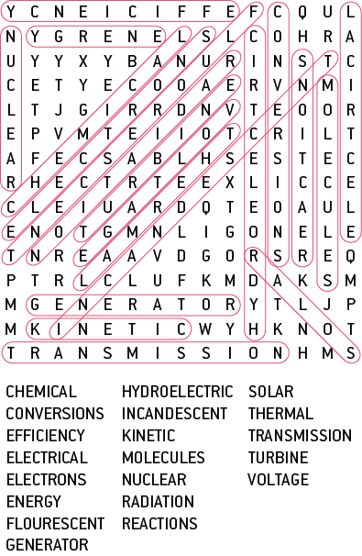

3.6 Science as a human endeavour: Energy efficiency can reduce energy consumption

Literacy support worksheet answers (pages 52–53)

Minimising energy consumption

1 A hair dryer has a fan and a heating element. How does each one work?

a Fan:

Electricity makes the fan motor spin (kinetic energy) and the heating element heat up (thermal energy).

b Heating element:

The air passes over the heating element, making the air hot when it comes out.

2 Many people try to reduce the amount of energy they use in their homes. How does this help us? State two reasons.

It would cost less to live as you use less electricity.

There is less impact on the environment.

3 Name four devices that heat either your home or your food:

Oven

Heater

Fireplace

Toaster, microwave, etc.

4 The following graph shows the overall energy consumption used in your household over the course of 24 hours, from midnight to midnight.

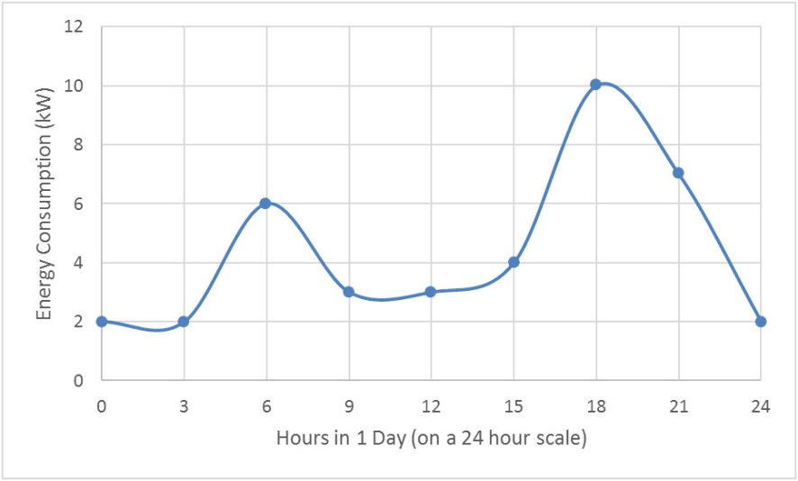

The spikes in energy consumption are at 6am and 6pm. Why do you think this happens?

6am: people wake up, turn on heater (in winter), shower, cook breakfast and get ready for the day.

6pm: people come home, turn on heater, tv, computer, cook dinner, turn on lights (it gets dark at 6pm) etc.

5 Every room in the house below uses energy in different ways. State one way energy use could be reduced in each each room. E.g. Dining room- turn the heater off when not in use.

a Bedroom 1:

Answers will vary – an example could be: Turn the electric blanket off.

b Bathroom:

Answers will vary – an example could be: Have shorter showers.

c Garage:

Answers will vary – an example could be: Make sure you turn the light off.

d Dining Room:

Answers will vary – an example could be: Make sure you turn the heater off when not in use.

e Kitchen:

Answers will vary – an example could be: Turn off appliances at the switch when not in use.

Word discovery

6 Boggle

Find and circle as many words as you can about minimising energy consumption in the puzzle below. The words can run up and down or left to right as well.

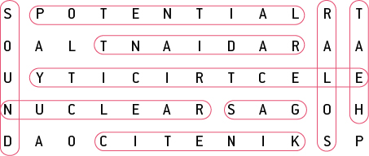

3.7 Science as a human endeavour: Solar cells transform the Sun’s light energy into electrical energy

Literacy support worksheet answers (pages 54–55)

Solar energy

1 What is a solar cell?

A solar cell is a device that transforms the Sun’s light energy into electrical energy.

2 View the graph on page 54. At what time is the solar energy producing the highest irradiance?

Noon.

3 Which three states produce the largest amount of solar energy?

Queensland

Northern Territory

Western Australia

4 Why do you think these states produce the largest amount of solar energy?

They have the most sun throughout the whole day.

5 Why were solar cells invented?

Solar cells were invented to store solar energy.

6 Fill in the flow diagram showing how solar cells (photovoltaic cells) capture light energy:

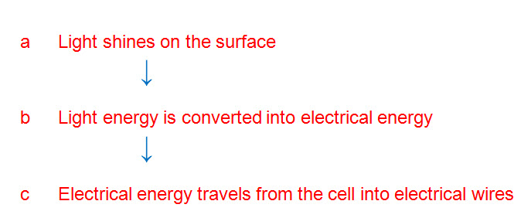

7 How energy efficient are photovoltaic cells?

30%

8 Why can solar cars only carry one person?

The lighter they are, the more energy efficient and the further they will travel.

9 Why do you think that using solar cars is not a practical method of transport?

If it becomes cloudy then the solar cells won’t work, and the same applies at night. Also, it only carries one person so it is not a family car.

10 In space, light travels at the speed of light (299 792 458 metres per second).

There is a distance of: 149 59 870 700 metres between the Earth and the Sun.



Use this equation to calculate how many seconds it would take for the Sun’s light to reach Earth:



11 Convert this time into minutes by dividing by 60.

8.3 minutes

Word detective

12 Draw and label

Draw and label a solar panel with photovoltaic cells using the words below. Include how it generates electricity.

Light Electrons Semiconductor Flow

Student drawings will vary.

3.8 Science as a human endeavour: Engineers use their understanding of energy to solve problems

Literacy support worksheet answers (pages 56–57)

Engineering

1 Briefly explain what each of these engineers does in a few words.

a Chemical engineers:

Combine existing materials and develop new materials.

b Mechanical engineers:

Design and improve things that have moving parts or have physical forces pushing and/or pulling them.

c Electrical engineers:

Design and organise electrical equipment.

d Civil engineers:

Research, plan and design structures.

2 For each of the tasks below, state which type of engineer would perform this job:

|  |  |  |
| --- | --- | --- |
| a Build a bridge  Civil engineer | b Build a satellite for NASA  Electrical engineer | c Robotics  Electrical engineer |
| d Build the longest waterslide in the world  Mechanical engineer | e Design and build a car to be raced at NASCAR  Mechanical engineer | f Design shatter-proof glass  Chemical engineer |
| g Build the tallest building in the world  Civil engineer | h Make a new type of plastic which is biodegradable  Chemical engineer | I Medical devices/equipment  Mechanical engineer |
| j The design of different types of paper  Chemical engineer | k The electronics of the CERN super-collider  Electrical engineer | l Dig and reinforce a tunnel between Victoria and Tasmania  Civil engineer |

3 Match the type of engineering assessment (on the left) with the relevant question on the right.

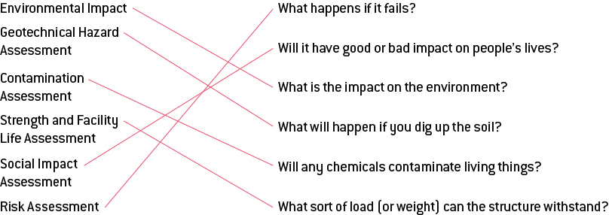

4 Your best friend develops an engineering proposal to build a waterslide from the kitchen, at the front of the house, through the house and out to the backyard so that:

a summer will be awesome, and

b you can easily get drinks and icy poles on hot days.

As the engineering expert, you will need to judge your friend’s proposal and think about the dangers of:

*Answers will vary.* Hopefully there are some entertaining ones!

a Environmental impact (i.e. the impact on the rest of the house if the waterslide runs through the house)

Floors, carpets and walls may be damaged by water – floors may need to be ripped out or covered up.

b Social impact (i.e. will the family be happy?)

Although your siblings/cousins/friends will love it, your parents will be **very** unhappy that their house is being destroyed.

c Risk assessment

If it fails, there will be a big cost involved in cleaning up not only the waterslide but also the house.

d Contamination assessment

The water will need to be chlorinated; this could kill any creepy crawlies in the house … BONUS!

e Strength and facility assessment

The loads will depend on the people on the waterslide, but it should be able to hold everyone if it is designed correctly and built out of suitable materials.

f Geotechnical hazard assessment (think about the floors)

The floors of the house will need to be dug up to fit the waterslide into the house, which will be a huge problem and very costly.

Word detective

5 Draw and label

Draw and label a diagram of the waterslide including the factors from a to f, above. Explain how each one would work or not.

Answers will vary but could include:

a Environmental impact: You would need to rip up floors and carpets, if not you would damage them with water.

b Social impact: Mum is unhappy. You are destroying your parents’ house, but your siblings/cousins/friends will love it.

c Risk: If it fails, there will be a big cost in cleaning up, not only the slide but the house.

d Contamination: The water will need to be chlorinated – this could kill any creepy crawlies in the house … which would be a bonus!

e Strength and facility: The loads will depend on the people on it, but it will be able to hold everyone.

f Geotechnical hazard: Digging up floors to fit it in is a huge problem and very costly.

Should the project go ahead? Why or Why not?

No,the project shouldn’t go ahead. It would be too expensive, there would be too much destruction and if there is one thing you never do, it’s upset your parents!